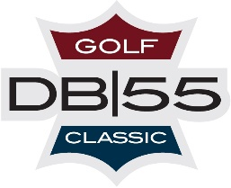

SPONSORSHIP COMMITMENT FORM

Please fill out the following information and return to Derrick Brooks Charities, in.

We , agree to become a sponsor for the 3rd Annual Derrick Brooks Pensacola Celebrity Classic on August 18th and 19th, 2024.

Mailing Address

Phone Number: Email Address:

Contact Name and Title:

Desired Sponsorship Level:

Payment

Check enclosed for payment of $ . Please make all checks payable to Derrick Brooks Charities.

Type of Card (Circle One): Master Card Visa American Express Discover

Name on Card:

Card Number: Expiration Date: Security Code

Address: City State Zip Code

Authorized Signature: Date:

PLEASE RETURN TO: DERRICK BROOKS CHARITIES 3750 GUNN HIGHWAY SUITE 109 TAMPA, FL. 33618 OR EMAIL TO:
BONITA PULIDO BONITA@DB55.ORG

A COPY OF THE OFFICIAL REGISTRATION AND FINANCIAL INFORMATION MAY BE OBTAINED FROM THE DIVISION OF CONSUMER SERVICES BY CALLING TOLL-FREE, WITHIN THE STATE, 1-800-HELP-FLA. REGISTRATION DOES NOT IMPLY ENDORSEMENT, APPROVAL, OR RECOMMENDATION BY THE STATE. PLEASE REFER TO NUMBER CH21739

